ATM-9202  Periodic Verification Unit | 
Instruction Manual
ATM-9202 Periodic Verification Unit is used to verify that the ACM Series Constant Ground Monitors are in proper working order.
TEST PROCEDURE :  - Unplug the power supply from the ACM1 unit.  - Plug the ATM-9202 Periodic Verification Unit (PVU) GROUND lead (Male Banana Plug on the bottom of the unit) to the common ground at the workstation.  - Connect the ATM-9202 BENCH Ground lead (cord with Male Phono Plug on the upper left of the unit) to the ACM-1 Ground plug-in on the back of the unit.  - Connect the power supply to the ACM1 power plug-in.  - The ACM1 bench LED should be green.  - Plug the ATM-9202 OPERATOR lead (Banana Male Plug) to the ACM-1 OPERATOR input.  - Press the OPERATOR push button on the ATM-9202 and the OPERATOR LED on the ACM-1 should change from a blinking red to green.  - Release the ATM-9202 OPERATOR push button and the OPERATOR LED on the ACM-1 should change to a blinking red, with momentary beeps up to a maximum of 7 to 12 beeps.  - Press the BENCH push button on the ATM-9202 and the BENCH LED on the ACM-1 should change to red, with constant beeps.  - Release the ATM-9202 BENCH push button and the System Ground LED on the ACM-1 should change to green, with no beeps.  - If the monitor did not pass as per the test procedure please contact Bokar International | 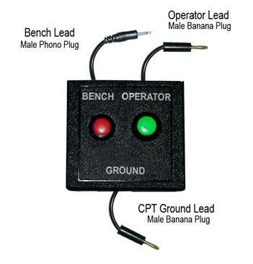

 | BOKAR International  650 Scranton Pocono Hwy.,  Covington Twp., PA 18444, USA
Tel: (570) 842-2812 Fax: (570) 842-4290 E-mail: bokar@bokar.com

www.bokar.com www.SMT-tool.com www.ESDmeters.com
www.ESDchair.com www.ESDcarts.net www.BestBatchOven.com
www.assembly-smt.com www.SMTpreheater.com www.SMTrepair.com
US Master Distributor: www.bomir.com

