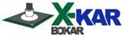 | XIL-2 Long life Illumination System for SMT rework
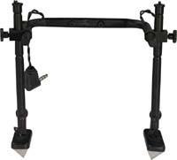
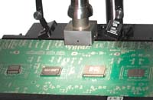
XIL-2
The system is meant to be used with XK-Series tool holders to give focused illumination exactly at the place of rework. Adequately illuminated PCB helps to position properly a fine pitch component, inspect paste deposition and inspect the quality of the solder joints after rework.
XIL-2 fits X-KAR XK-Series Tool Holders produced after Jan 2007.
It does not occupy require a bench space and can be installed on the XK holder in few minutes.

Features:
- Adjustable distance from the board independently on both sides.
- Full rotation and the adjustment of the illuminating heads.
- White, high intensity soft light
- Long life LED’s guarantee min 50 000 hours of operating time.
- System includes:

Technical Specifications:
Power Supply Voltage: | Input: 110-120 or 220-240V AC Output 12V DC
Power consumption | Max. 2 VA
Weight | 1.1 lbs. (0,5 kg)
System dimensions | 15.7"x5.9"x7.9" (400 x 150 x 200 mm)
Packaged weight | 1,5 lbs. (0,7 kg)

Optional equipment:
- Power Supply X-AC1 for 115V or X-AC12 for 220-240V. Needed when you have Pre-heater Based Rework System manufactured before October 2005).
- XCC-2L - Cord connecting XIL-2 with Pre-heater Based Rework System SMT-SerwiCE or Preheaters X-1001 (only for systems manufactured after October 2005).

Application:
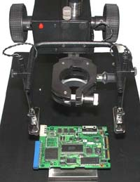
XIL-2 attached to XK-3AL

XIL-2 improves the efficiency and speed during placement or replacement of the SMT components using X-KAR Rework Equipment including XK Holders.
